Alfaro, Hannah C. Application Development and

BSIT 3-A Emerging Technologies

**Profile Link**: <https://github.com/hxnnhlfr>

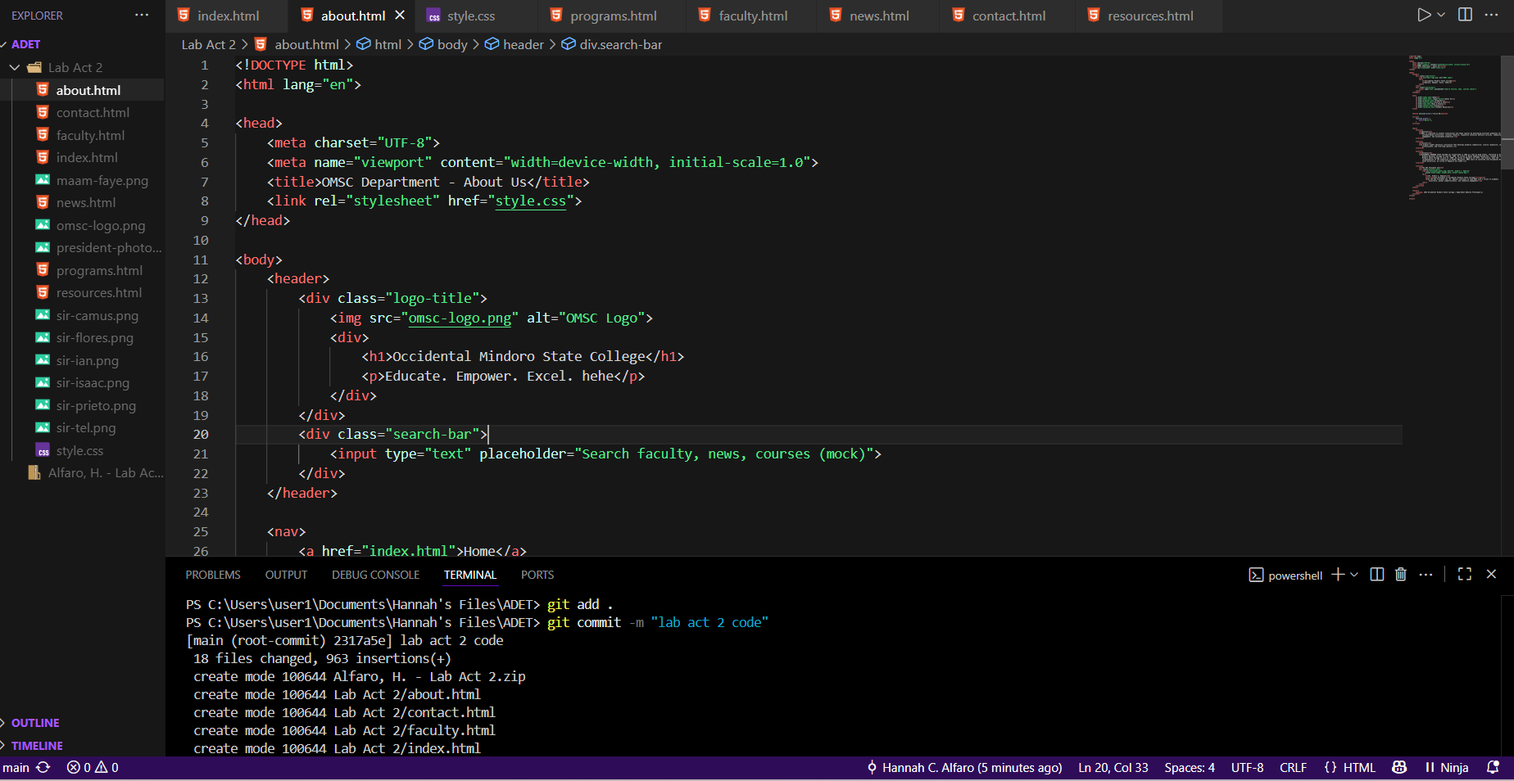

To prepare my files to be saved in Git, I type the command **git** **add .** in the Visual Studio Code terminal.

To save the staged files with a short description, I type **git commit -m** “*then the message here*”.



To upload my commits to GitHub, I type **git push** in the terminal.

To download the latest version of the repository from GitHub to my laptop, I type **git pull** in the terminal.